HARVEST TIMING CLARIFICATIONS
Br. George Tabac December 6, 2015

At a recent convention there was a panel discussion that was entitled, “If you knew you were going to be giving your last discourse, what would you talk about?” I don’t know for sure if this will be my last discourse, but I feel it may be. I prayed about it for many months, wanting to leave a message that would be a lasting blessing.

For myself, and I’m sure it’s true for all of us, to know the truth of our Heavenly Father’s plans is the greatest gift one could ever receive! It’s the motivating principal of our entire life. We cherish the Harvest Message given to us by our returned Lord through Br. Russell. So brethren, it is my prayer that what may be my last talk, will in some small way result in even a greater love and appreciation of the Harvest Message we all cherish.

Today we would like consider how Br. Russell in his own words made a few harvest timing clarifications that to me make the Harvest Message even more beautifully harmonious. Also to share with you a facet of truth that I never knew before, that strikingly correlates with Br. Russell’s clarifications.

*********************************

I would like to begin by reflecting on what we all felt Br. Russell originally taught.

Lord’s Return began in 1874, - at which time the 1000 year reign of Jesus and the Church began and would last until the year 2874.

The 1000 year reign would be the same period of time as the 1000 year binding of Satan which would run concurrently with the 1000 year reign of Jesus and the Church, from 1874 to 2874.

We saw how 1874 was the chronological end of the 6000 year reign of sin and death, followed by the seventh 1000 year Millennial day of blessing, again nicely parallel with the other two 1000 year periods.
Then 2874 would usher in the 50 thousandth year Grand Jubilee.

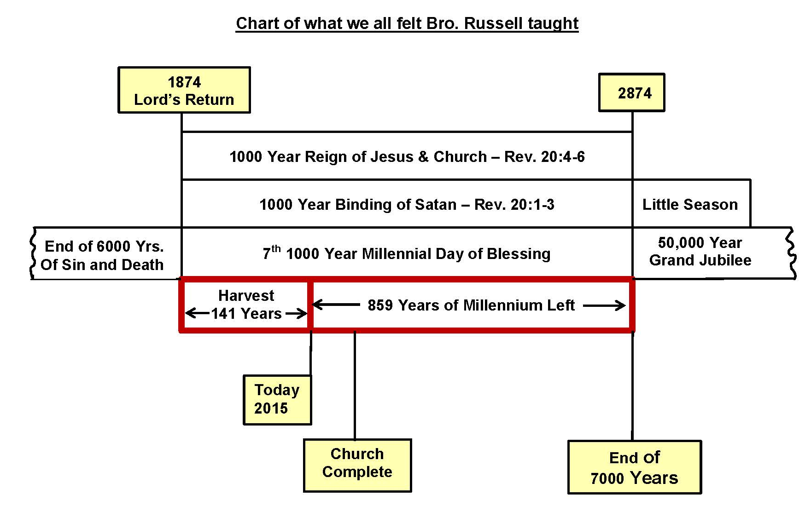

We also realized the first portion of the Millennium is the Harvest which started in 1874 and up to today in 2015 has lasted 141 years, leaving 859 years left of the Millennium. This in essence is what Br. Russell taught.

Now I’d like to proceed to consider articles where Br. Russell refers to the Mediatorial Reign being 1000 years.

We’ll quote just a few of many:

QB – 467
There can be no mediatorial work between God and men until the Body of the Christ is complete and the mediatorial kingdom begins, and it will last through all of the thousand years,

R-5928
The Great Mediator between God and man--The Christ of glory--will fill His mediatorial office for a thousand years.

Harvest Gleanings 2
It is the thousand-year day of Christ, the period of His mediatorial reign, in which Satan will be bound

We may recall there are many similar references to the 1000 year Mediatorial reign in the Harvest Message. We have printed 7 pages of 56 quotations on our hand out that you may want to read at home. What we find is:

Br. Russell is 100% Consistent in ALL Mediatorial Reign Articles
1. The Mediatorial reign cannot begin until the Church is complete, and blood is applied to Justice.
2. The Mediatorial Reign will last for 1000 years during which Satan will be bound, and it will end at the start of the little season.

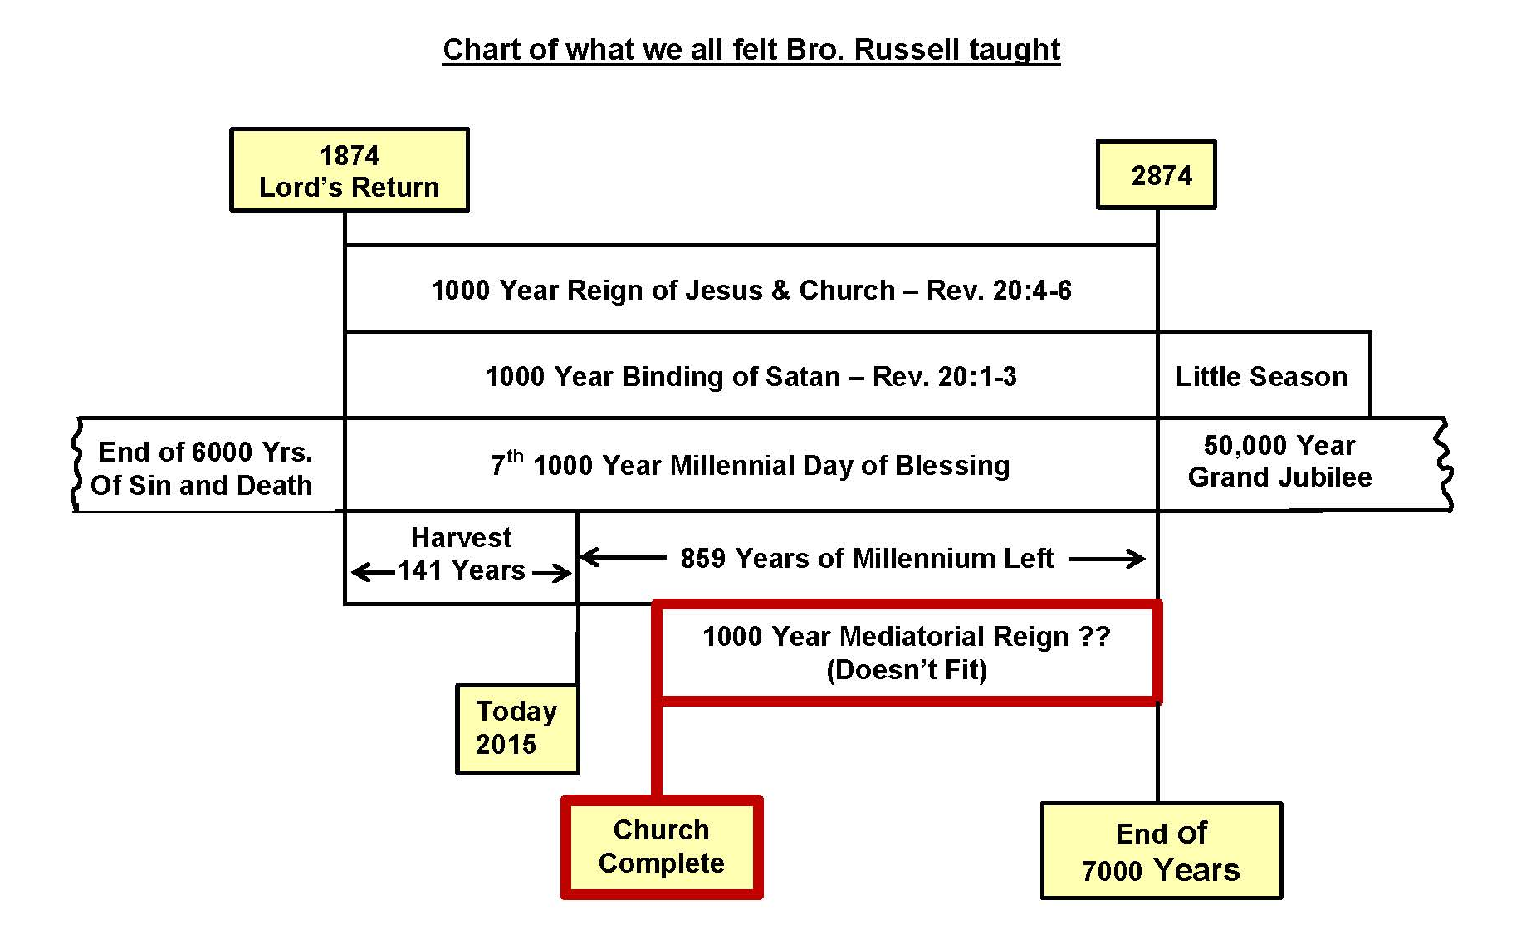
Now when we try to plot the Mediatorial reign on our chart of what we all have believed, we have a problem. We know the Mediatorial reign:
- Can’t start until the Church is complete,
- That it is to last for 1000 years,
- And will end at the start of the Little Season. We can see there’s no way this can fit into our chart.

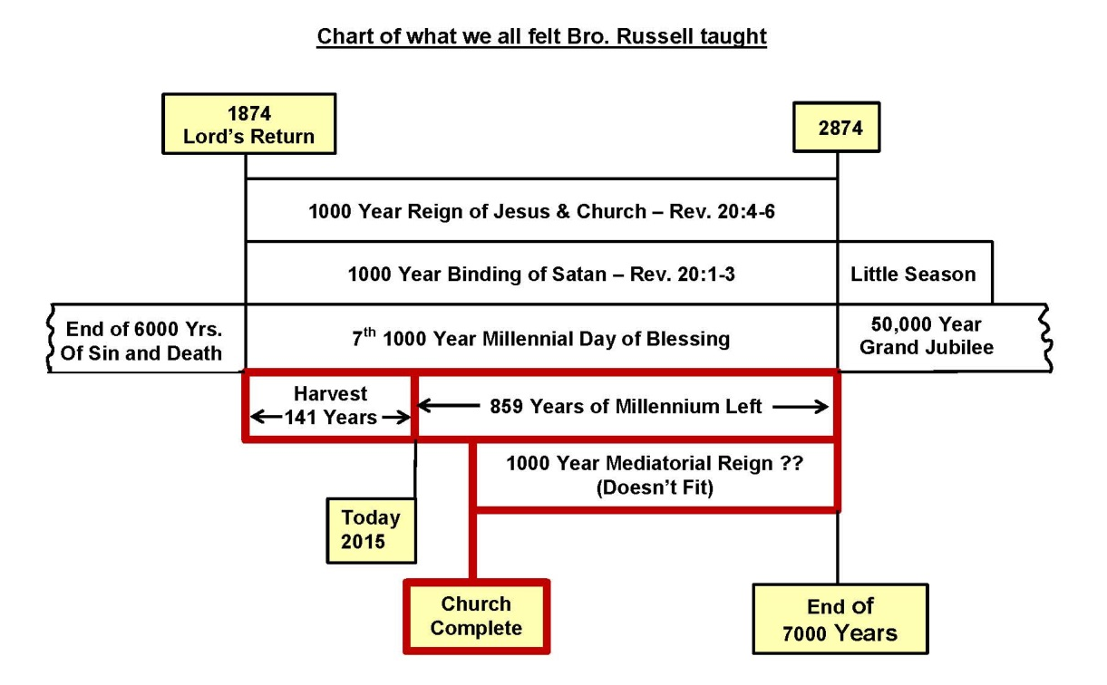

For we are already 141 years into the Millennium and the church is still not complete. But, even if the church was complete today, there’s only 859 years left to the Little Season. There’s no way the 1000 year Mediatorial period can fit into our present understanding chart before the Little Season. How can we harmonize this?

Shortly brethren we will present a clarified chart based on Br. Russell’s own writings, where he made clarifications that will show how this problem can be solved, as well as other seeming dilemmas that have come to mind that we each have endeavored to harmonize or rationalize in our own minds one way or another.
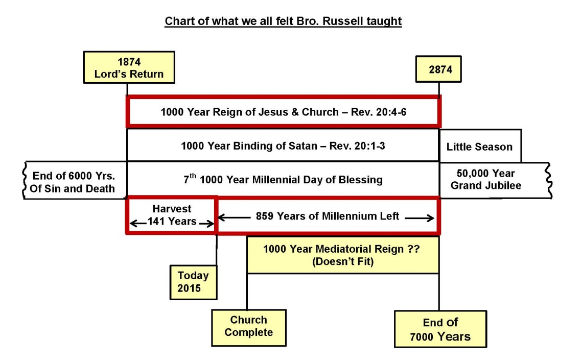

Such as, the church was to live and reign as priests for 1000 years starting in 1874. Yet we’re still here after 141 years, not yet reigning as priests, and there’s only 859 years left of the Millennium.
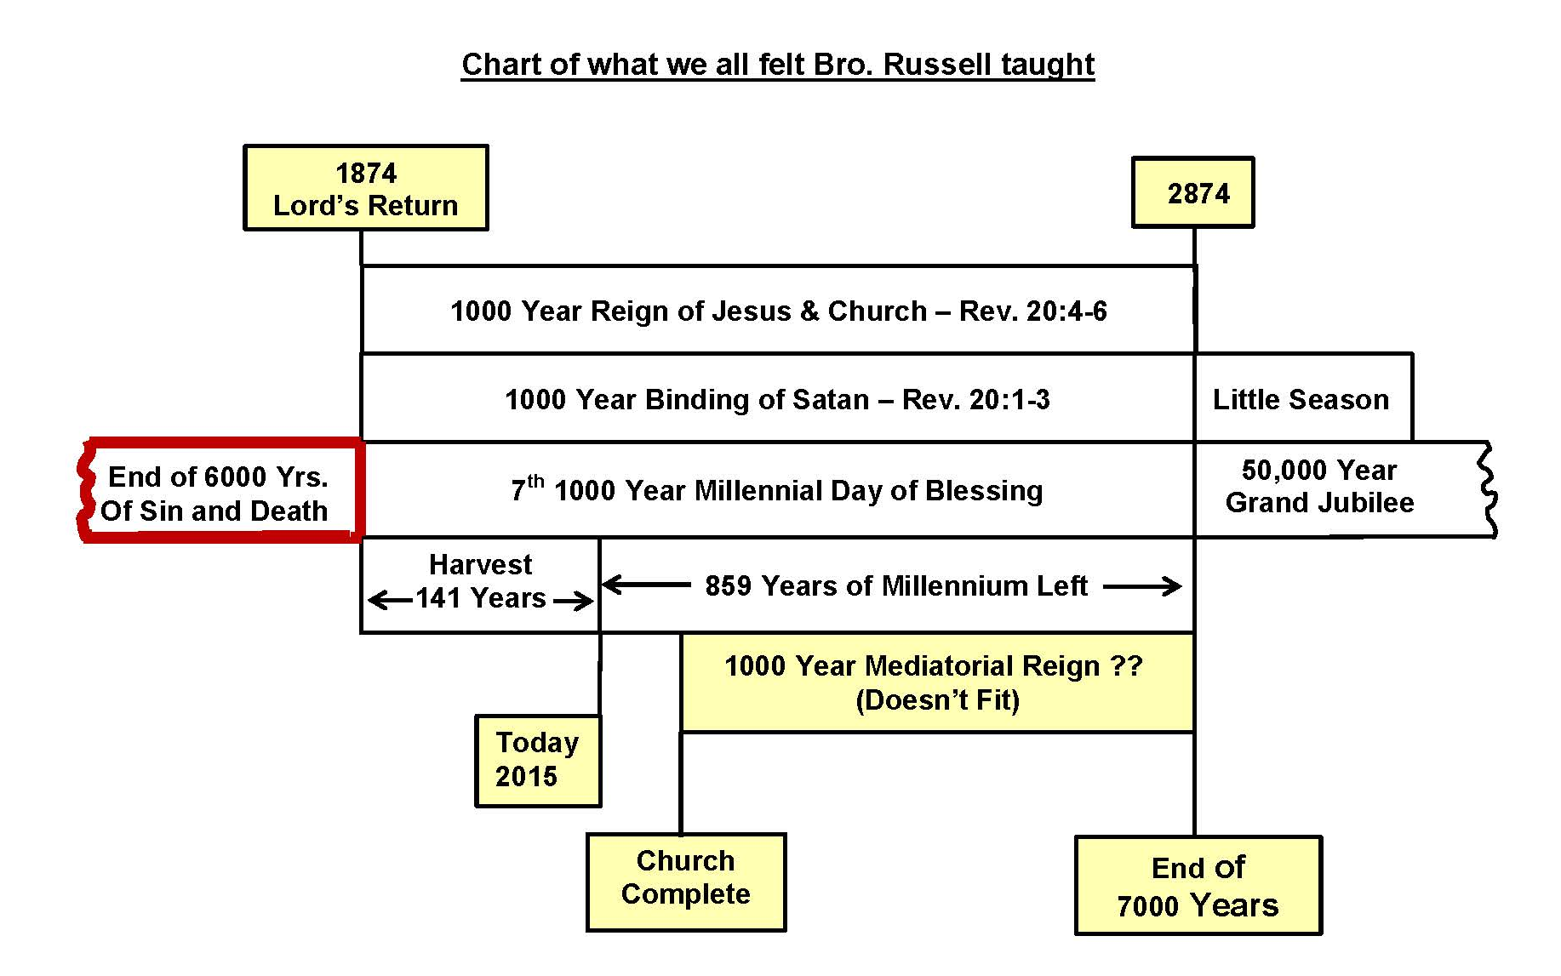

A second problem is 6000 years of the reign of sin and death was up in 1874;
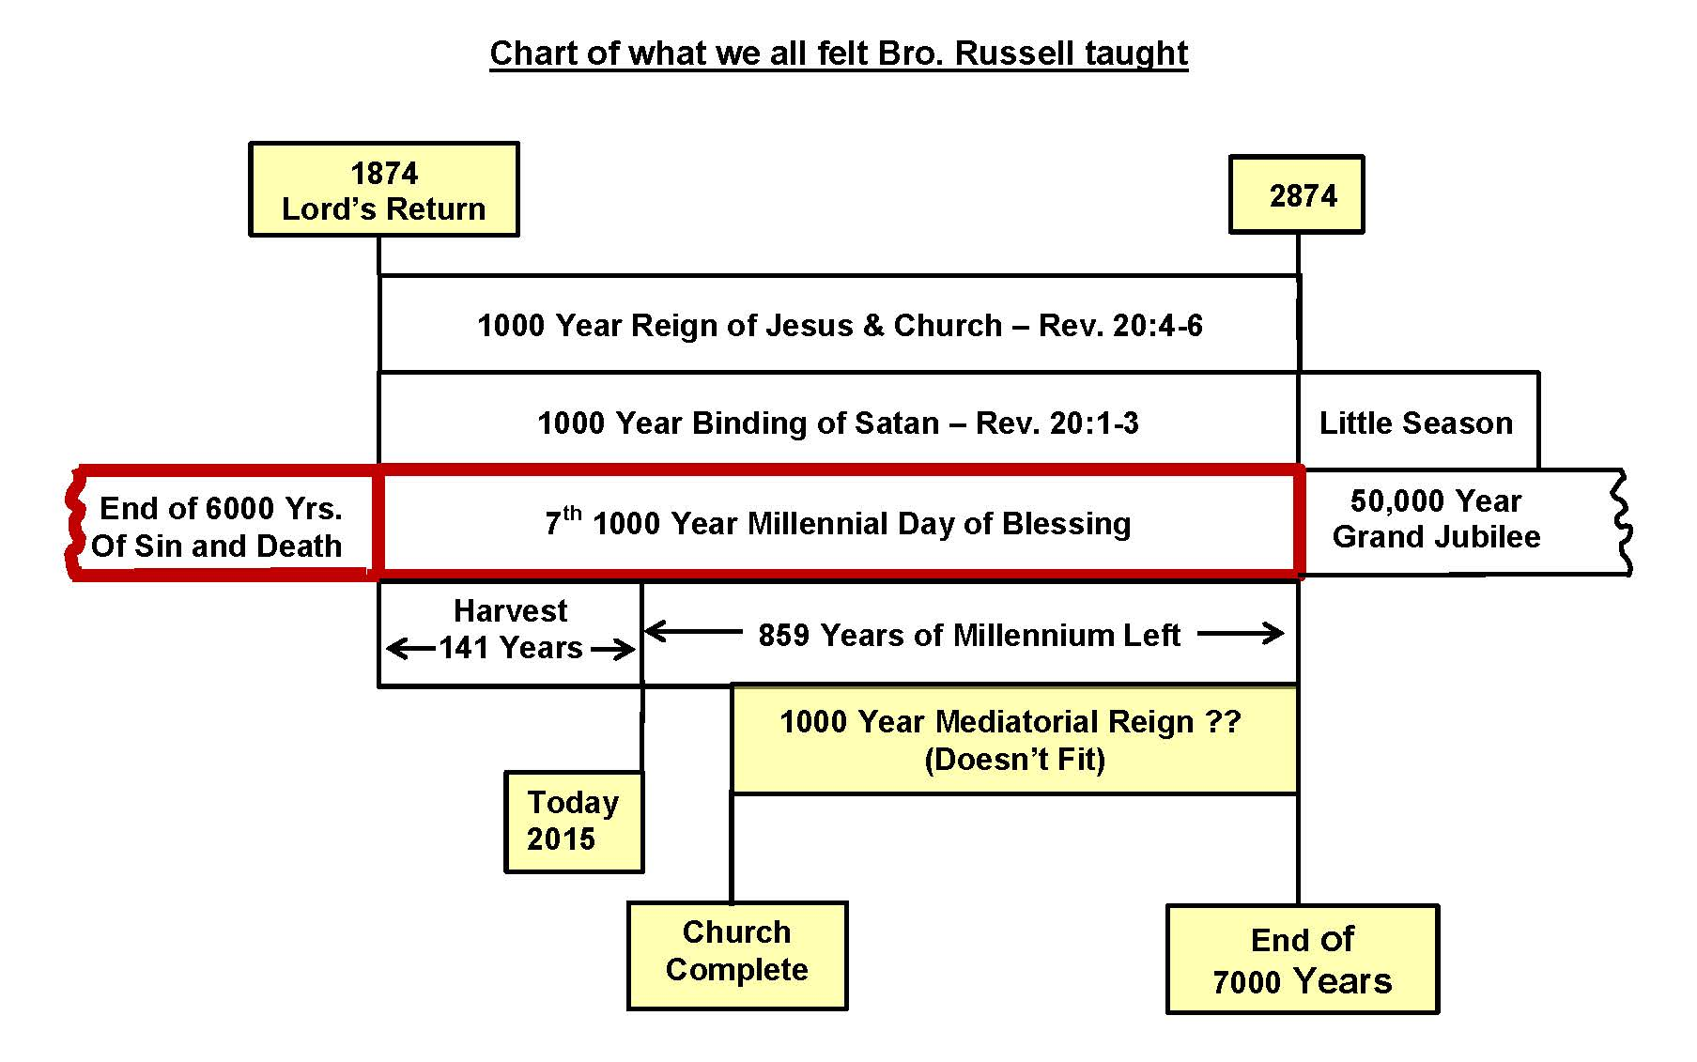

Followed by 7th 1000 year Millennial day of blessing. The Millennium:

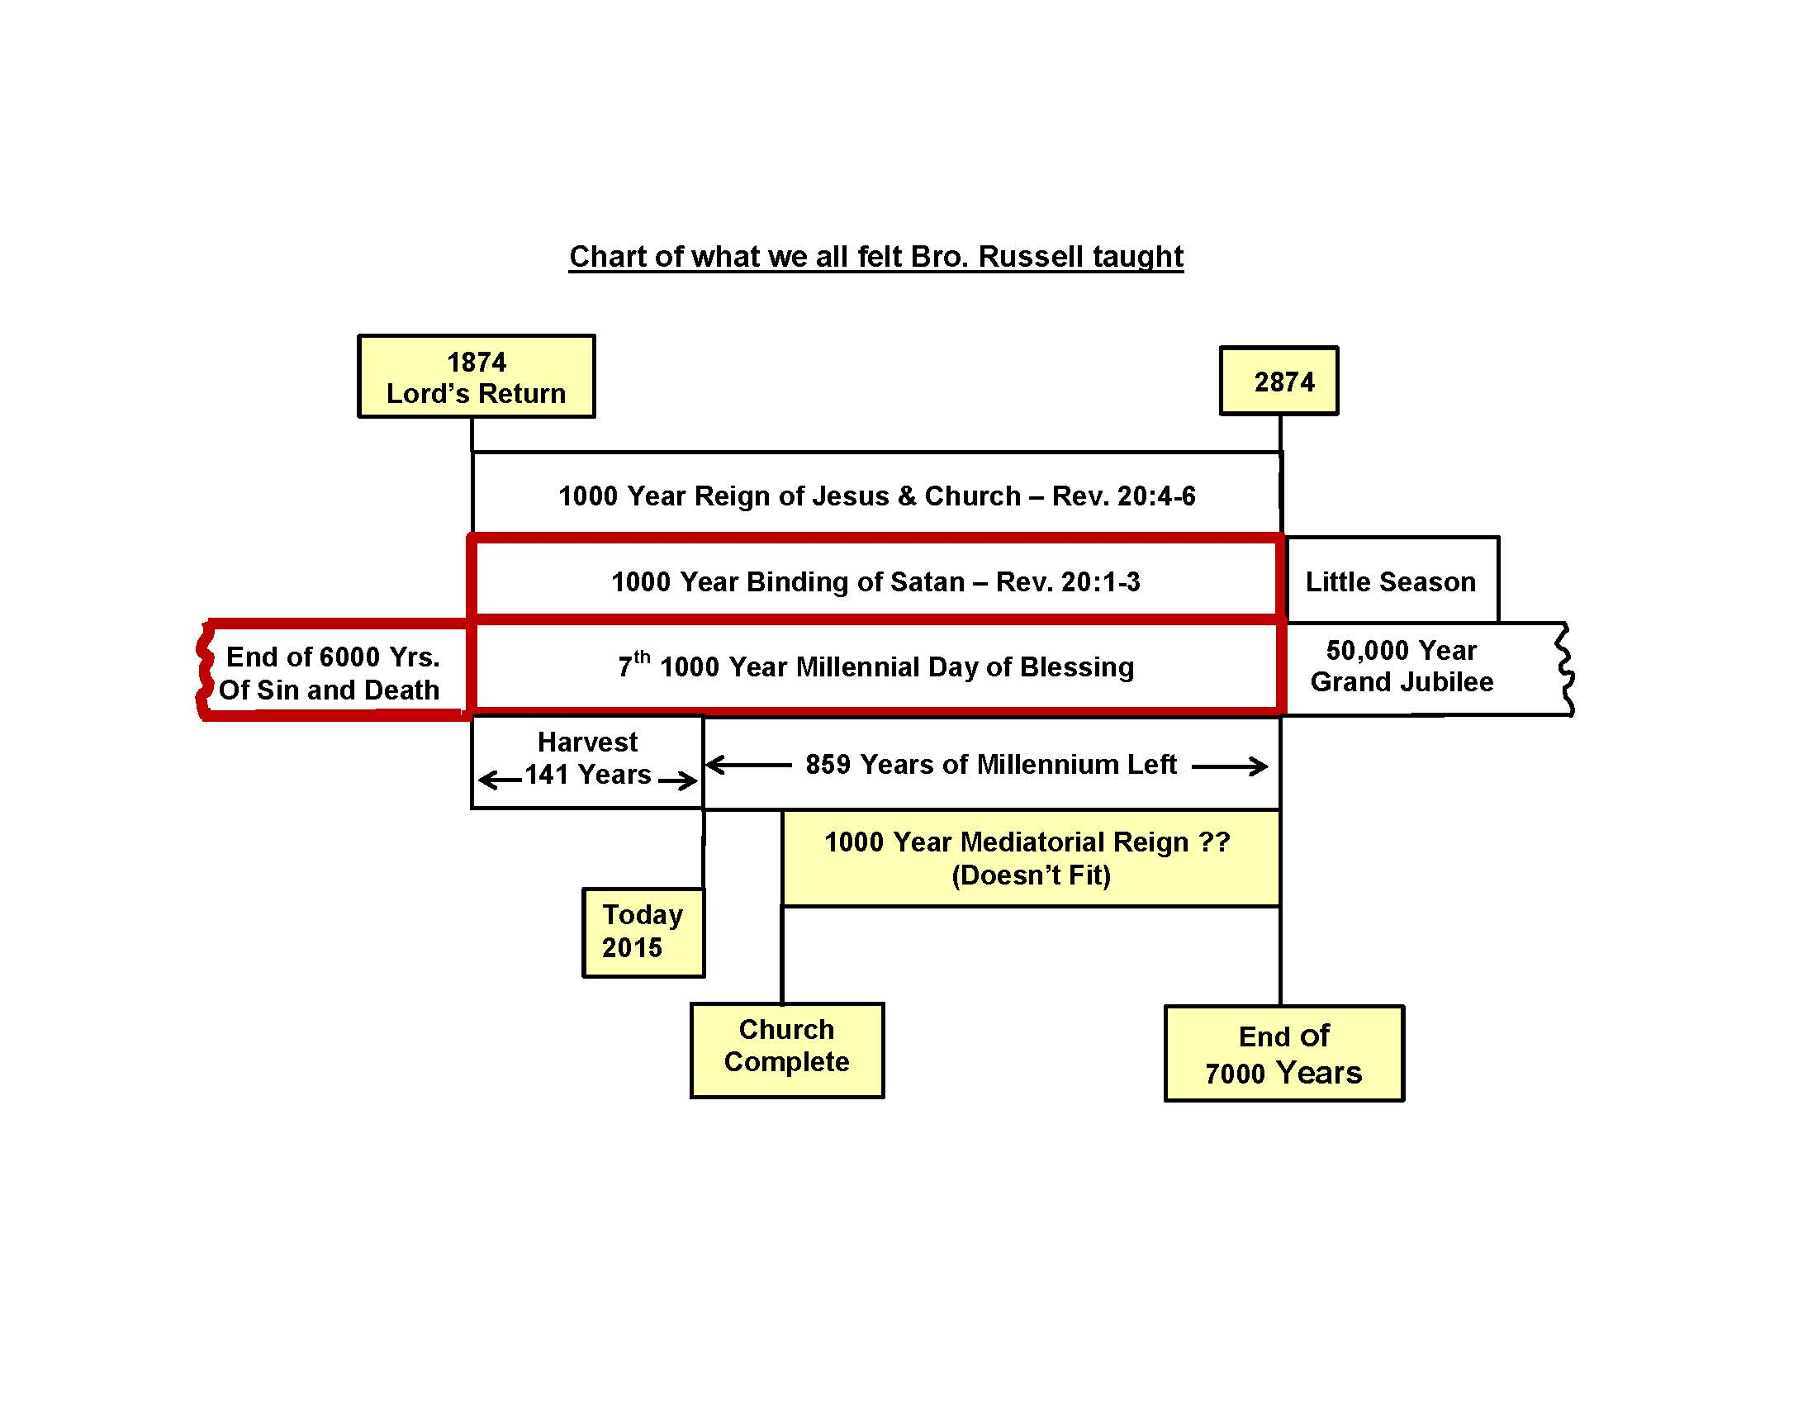

Which was to be the same time when Satan was to be bound for 1000 years. But as we’ve considered the last 141 years of the Harvest we realize sin & death still continues and Satan is far from bound. In fact since 1874 over 150 million people have been killed in wars alone instigated by Satan. And today Satan continues to influence terrorists to kill thousands of innocent people, some by grotesque beheadings.

A chart of Br. Russell’s clarifications will shortly answer these seeming dilemmas, as well as that raised in reprint 5023 written in1912..

R-5023 Written In May 1912

Question: "Is it scriptural to say that the glorified members of the church have reigned at any time up to the present?

Answer: No! They have not reigned at any time….The reign of Christ did not in any sense begin in the past…When the reign of Christ begins, you will find it such a thorough reign that all the members of his body will have some part in it.

Previously we all concluded the reign of Christ & the church began in 1874. But here in 1912 Br. Russell clarified in no sense have the church reigned in the past. The article I have in mind where Br. Russell would clarify all these concerns in his own words starts with a question.

R-2739
QUESTION:"I understand from Rev.20:4-6, that Christ will reign 1000 years, and from verses 2-7 that Satan will be bound during that period. If Christ began to reign in 1878, and Satan will not be bound until 1915, the two periods do not seem to synchronize; and furthermore, both extend beyond the 7th 1000 year period which according to our Bible chronology, began in the Autumn of 1872. How is this? Can you assist me?

ANSWER: Apparently this matter of when the 1000 year period should be reckoned as fully beginning and fully ending will be an open question until the close of the Millennial age.
The scripture declaration respecting the saints, the overcomers is, 'They lived and reigned a 1000 years.' The reign of the saints cannot be properly be said to begin before all the 'jewels' have been gathered, nor before 'the times of the Gentiles' end in 1914. Nor is it said that their reign will be no longer than a 1000 years. After the 1000 years Satan shall be loosed and the above trial shall ensue; but the reign of Christ and the church will evidently continue long enough after the 1000 years to destroy all found unworthy in that final test, and to thus complete the work for which this reign is instituted.

Brethren I believe this article holds the key to gaining a greater harmony of Br. Russell’s writings, and harmony amongst ourselves as brethren. We all know Br. Russell is the Harvest Messenger used by our returned Lord as the 7th messenger to bring us meat in due season.

Yet on occasions he realized he needed to make clarifications when he made unwarranted deductions, as in stating the church would be complete by 1914, and all Gentile kingdoms would have been removed by 1914. I think we can see Br. Russell is making further clarifications.

In fact, I believe if Br. Russell was living today 141 years after 1874, he would make a clarified chart similar to one we will shortly show. Let’s now consider Br. Russell’s answer step by step.

ANSWER: Apparently this matter of when the 1000 year period should be reckoned as fully beginning and fully ending will be an open question until the close of the Millennial age.

First of all we note Br. Russell indicates the matter of the 1000 years was difficult for him to pin down positively. It wasn’t clear in his own mind, adding the words “apparently it will be an open question until the end of the Millennial age.” We continue with his answer:

The scripture declaration respecting the saints, the overcomers is, 'They lived and reigned a 1000 years.' The reign of the saints cannot be properly be said to begin before all the 'jewels' have been gathered, nor before 'the times of the Gentiles' end in 1914. Nor is it said that their reign will be no longer than a 1000 years.

Most of us have believed the reign of Christ began in 1874 as stated many times in the Harvest Message. But we notice in the 1912 article we just read, as well as in this article, that the reign of the SAINTS cannot begin until the Church is complete, and it would have to be some time after 1914.

We believe Br. Russell is telling us here that the reign of our Lord and the reign of the saints, are two different and distinct entities. Which I would like to show in the following Harvest Timing Clarification chart.
Harvest Timing Clarifications

Our Lord’s reign that did begin at his return in 1874. For he returned with a crown upon his head to begin the Harvest work, and authority to remove Satan’s evil empire. His reign would continue as the head of the Church to the end of the little season, thus it would be longer than a 1000 years.

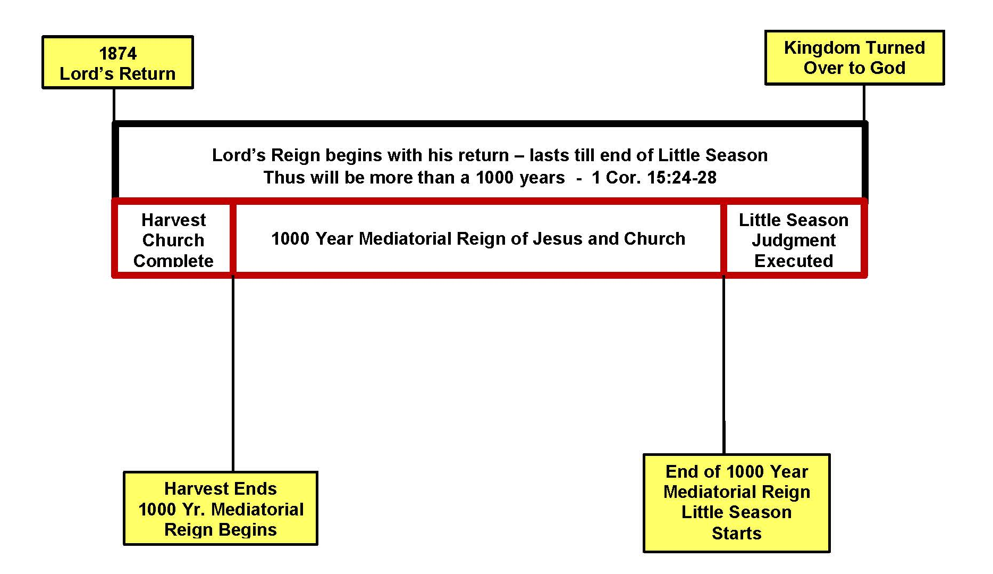
Harvest Timing Clarifications

The second aspect of the Lord’s reign is the 1000 year Mediatorial reign of Jesus and the Church, which we know can’t begin until the church is complete, and it would last for a 1000 years to when the Little Season starts.

Harvest Timing Clarifications
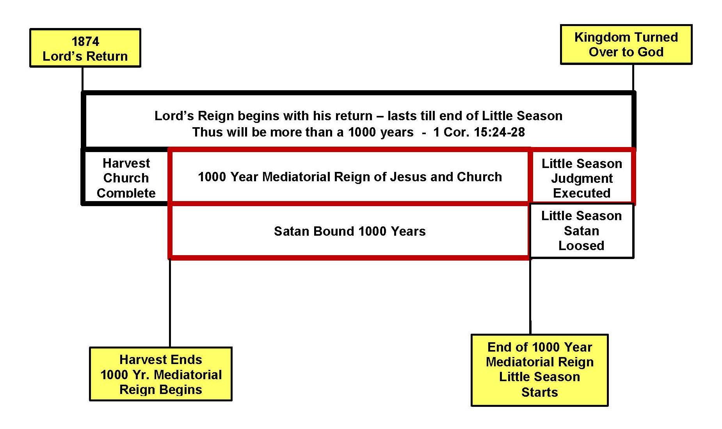

The 1000 year Mediatorial reign of Jesus and the church would be the same time period as the 1000 year binding of Satan.

***************************

Can we see how beautifully this clarified article harmonizes all aspects of the 1000 year periods.

- Our Lords reign did begin in 1874, and will last till the end of the Little Season!

- The 1000 year Mediatorial reign of Jesus and the Church will begin when the Harvest is over and the church is complete,

- And this will be the same time Satan will be bound for a 1000 years.

*********************************

Coming back to our original chart of what we all felt Br. Russell taught, there is one other area that we’d like to explore further. It has to do with 1874 being the end of the 6000 years of the reign of sin & death, which was followed by the 7th Millennium and the binding of Satan.

But realistically I think we can all see how sin and death have continued after 1874, and Satan is far from bound. How do we harmonize this? Could it be that the end of 6000 years also needs to have some further clarification?
In Volume 2 – Page 39 we read:
Volume 2 - Page 39
“Though the Bible contains no direct statement -that the seventh thousand [year] will be the epoch of Christ’s reign, the great Sabbath Day of restitution to the world, yet the venerable tradition is not without a reasonable foundation.”

The venerable tradition was there would be 6000 years of sin and death, - followed by a 1000 year Sabbath of festitution and blessing. With this in mind I’d like to add another line to our CLARIFIED CHART.

Harvest Timing Clarifications
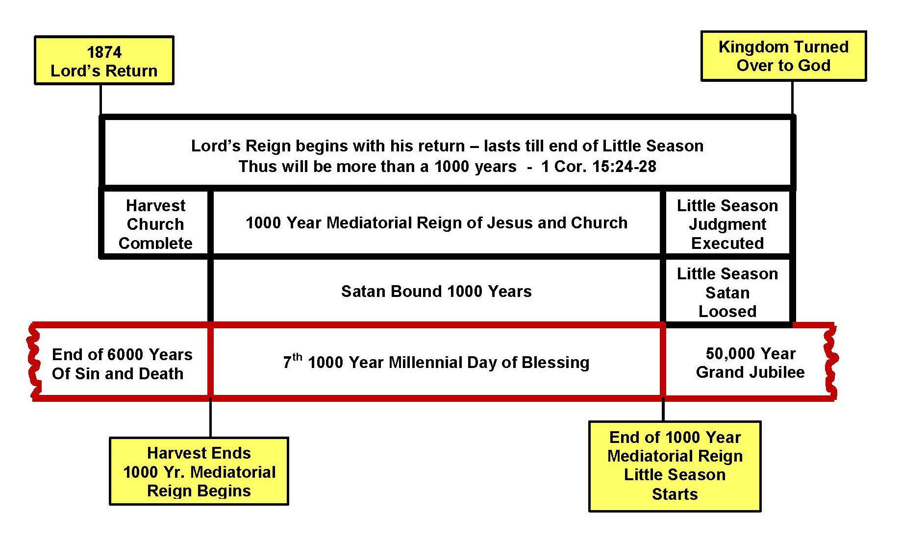

Since we know the 1000 year Mediatorial reign can’t begin until the Church is complete, and this is the same period of time that Satan will be bound for a 1000 years, it follows that the 7th thousandth year Millennial day of blessing would be the same period as the Mediatorial Reign and Satan’s binding.

This in turn would naturally imply that the 6000 years of sin and death would END when the harvest was over and the church was complete. For then the 7th one thousand year Millennial day of blessing would commence, simultaneously with the Mediatorial reign and Satan’s binding.

But if that were so it would require an adjustment to our 6000 year chronology. Could that be possible??

I must say, this aspect of our chart was not spelled out in the clarified article of Br. Russell we’ve been considering. We believe one of the reasons Br. Russell didn’t make an adjustment to the 6000 year chronology was because he died before the discovery of many recent biblical, historical and archeological discoveries were made that would indicate an adjustment would be in order in our 6000 year chronology.

*******************************
One of them I would like to share with you today sheds further light on the aspect of calculating the 6000 year chronology.
In our 2nd Volume chronology we’ve seen how its fairly simple and straight forward to calculate step by step the length of time from the creation of Adam up to the exodus from Egypt. It’s in Volume 2 - on pages 43-47.

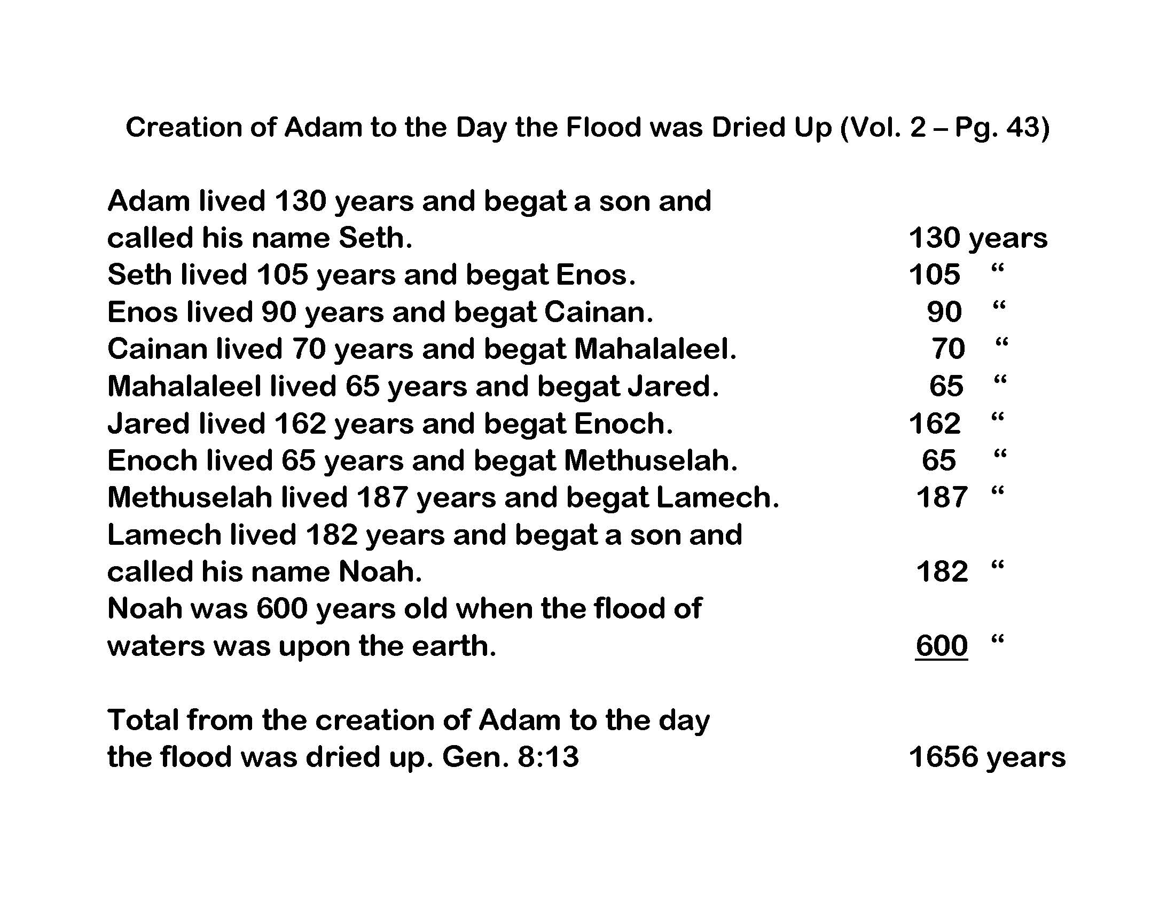

Adam lived 130 years and begat Seth, - Seth lived 105 years and begat Enos, and so on. Thus the total from Adam to the flood was 1656 years.

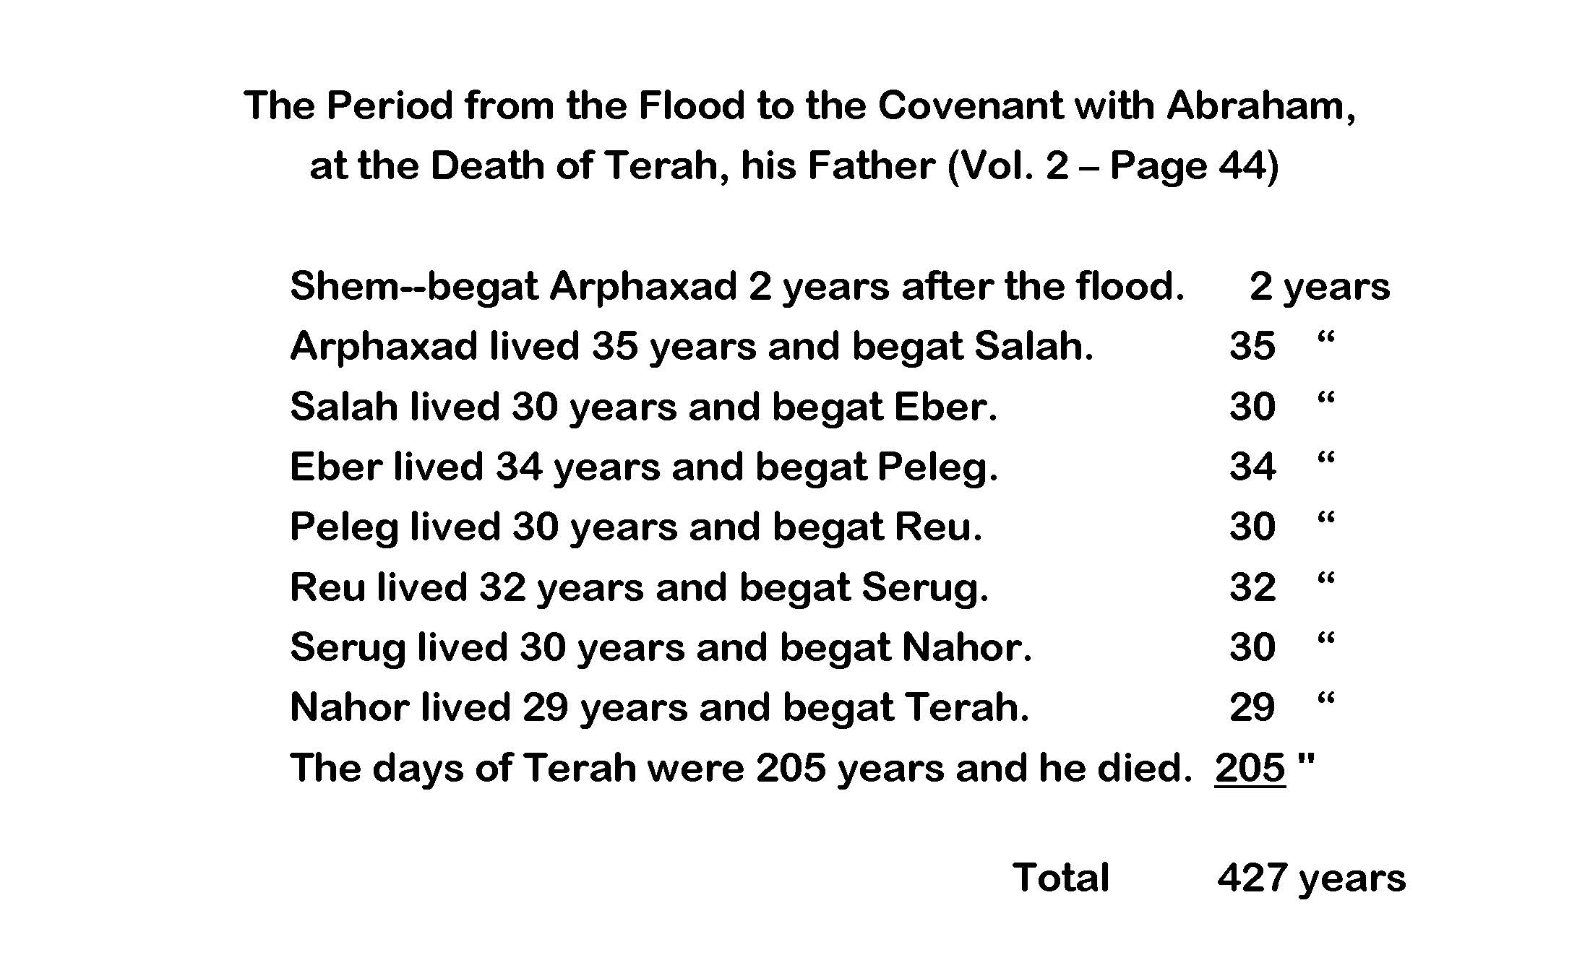
From the flood to the covenant with Abraham is also easy to calculate. The Total is 427 years. The next step is on Vol. 2 page 44-47.

Volume 2 page 44 - 47
The period from the Covenant with Abraham to the giving of the law at the Exodus

Paul declares that the Length of this period was 430 Years in Gal. 3:17

All of this is rather straight forward that we’re all familiar with. Now we would like to go on to what Br. Russell refers to as the most difficult portion of chronology having to do with the period of the Judges.

Volume 2 page 49

The Period of the Judges

We come now to the most difficult portion of chronology, the period from the division of the land to the anointing of Saul as king. It is usually termed the period of the Judges, though the Judges did not fill the office continuously.

The record given in the books of Judges and 1 Samuel mentions nineteen periods, approximating a total of four hundred and fifty years; but they are disconnected, broken, lapped and tangled so much that we could arrive at no definite conclusion from them, and should be obliged to conclude as others have done, that nothing positive could be known on the subject, were it not that the New Testament supplies the deficiency.

Paul states that after God divided their land to them by lot, “He gave unto them Judges about [during] the space of four hundred and fifty years, until Samuel the Prophet. Afterward they desired a king, and God gave unto them Saul.” Acts 13:19-21

Let’s consider the Old Testament scripture Br. Russell is referring to that covers the period of the Judges from the Exodus, all the way to the 4th year of King Solomon’s reign. Its 1 Kings 6:1.

1 Kings 6:1
1 ¶ Now it came about in the four hundred and eightieth year after the sons of Israel came out of the land of Egypt, in the fourth year of Solomon’s reign over Israel, in the month of Ziv which is the second month, that he began to build the house of the LORD.
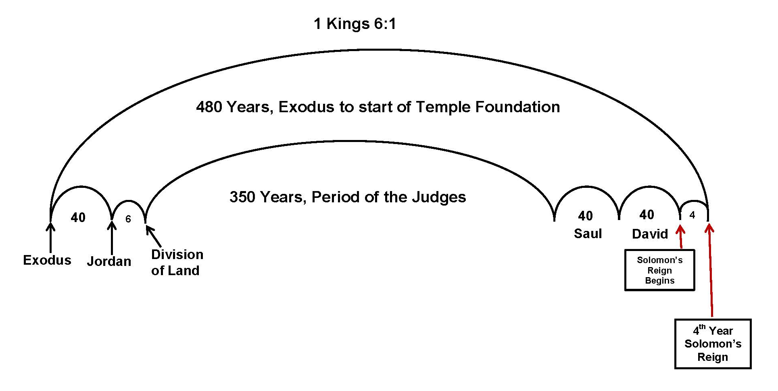

In chart form 1 Kings 6:1 is telling us its 480 years from the Exodus to the start of building the temple in the 4th year of Solomon’s reign. If we remove the five known periods, 40 years in the wilderness, 6 for the division of the land, and 40 for Saul and David’s reign, plus the 4th year of Solomon’s reign it leaves 350 years for the period of the Judges.

However we realize there is a problem with this scripture that has caused it to be debated for many years. Because Paul says in Acts 13:20 that he gave them Judges for 450 years, not 350.

Acts 13:20 K.J.
…and after that he gave unto them judges about the space of four hundred and fifty years, until Samuel the prophet.

Those students who felt 450 was more realistic than 350 (to fit in all the judges mentioned,) it was reasoned 1 Kings 6:1 must be a scribal error when it leaves only 350 years for the Judges not 450 as Paul stated.

Brethren may recall the footnote in the Diaglott for Acts 13:20 which gives a possible answer, in that there’s only one tiny line difference between the number for 4 and 5, and a scribe might have left it out. Which would make 580 years instead of 480 from the Exodus to the building of the Temple.

This could have been a possibility, however not very likely.

For No Old Testament manuscripts that have been found to date, including the Dead Sea Scrolls have the characters used for numbers (“480”) but rather they are written out in full like we do on checks – “Four Hundred Eighty.”

***********************************

But how do we harmonize Acts 13:20 in the King James Translation which states the period of the Judges was 450 years not 350 as in 1Kings 6:1?

Until recently most all of us myself included, as well as Br.Russell have accepted the Acts scripture feeling there must be a mistake in 1 Kings 6:1.

But brethren we would like to share with you a recent discovery for me that shows the mistake is not with 1 Kings 6:1 but with Acts 13:20.

The King James Bible written in 1611 has many mistakes as compared to the three oldest more accurate manuscripts, - the Siniatic, the Vatican 1209, and the Alexandrian.

But how can we know what scriptures are spurious and need to be changed based on the three oldest manuscripts?

Title Page of
Topical Index for Studies in the Scriptures and Other Helps

The easiest way is to use a book recently printed by the New Brunswick Ecclesia entitled “Topical Index for Studies in the Scriptures, and Other Helps.” It’s very helpful in looking up things in the Volumes by topics.
But an additional great help in the back of the book are the notes of Constantine Tischendorf a Greek Scholar that compared the King James 1611 bible with the three oldest manuscripts. And for every verse where any of the three oldest manuscripts differ from the King James he has a note that spells out the manuscript difference from King James. The following is:

Tischendorf’s Notes on Acts 13:19,20
(SVA is an abbreviation for Siniatic, Vatican, Alexandrian)
Notice they ALL Read

19-20 SVA “he distributed their land to them for an inheritance, about four hundred and fifty years. And after that he gave unto them judges unto Samuel the prophet.”

The important aspect we want to note is that all 3 of these older more accurate manuscripts read that he gave them judges, - after a 450 year period, that preceded the judges that we’ll cover shortly. They do not say that he gave them judges for 450 years as the incorrect King James translation has.

Incorrect Acts 13:20 King James 1611 Translation

… and after that he gave unto them judges about the space of four hundred and fifty years, until Samuel the prophet

As a result of this incorrect King James translations, we, Br. Russell, and others have used this scripture to show that 1 Kings 6:1 must be wrong because it would only allow 350 years for the Judges, while Acts 13:20 tells us it was about 450 years.

But brethren what the three oldest most accurate manuscripts now tell us, is it’s the King James rendering of Acts 13:20 that is incorrect, not 1 Kings 6:1.

Let’s now read the context of Acts 13 to see what are the 450 years being referred to that preceded the Judges.

Acts 13:16-20 NAS
16 And Paul stood up, and motioning with his hand, he said, "Men of Israel, and you who fear God, listen:
(Here Paul begins to give a brief 450 year recap of what preceded the period of the Judges,)

17 "The God of this people Israel chose our fathers,
(the 450 year period starts when Israel’s father was chosen by God.)

…and made the people great during their stay in the land of Egypt,
(Paul continues with noting how Israel increased in numbers while in Egypt.)

…and with an uplifted arm He led them out from it.
(Miraculous events of the Exodus from Egypt are brought to mind.)

18 "And for a period of about forty years He put up with them in the wilderness.
(The exodus was followed by 40 years of wandering in the wilderness.)

19 "And when He had destroyed seven nations in the land of Canaan, He distributed their land as an inheritance.
(Finally after 450 years Israel received their promised inheritance.)

...all of which took about four hundred and fifty years.
Paul is telling us it took about 450 years from the time Israel’s inheritance was promised (when God chose their father,) - to actually receiving the inheritance.

20 And AFTER THESE THINGS He gave them judges until Samuel the prophet.
(After all the events recapped above, God then gave them judges.

Thus, we want to note the 450 years in this context based on the more accurate oldest Greek manuscripts, is NOT telling us the length of the period of the judges, but how long it took from the giving of the promise to actually receiving it. Verse 16 told us the 450 years started from the time God chose Israel’s fathers, (plural) which we will shortly see was at the birth of Isaac, followed by Jacob. Why would choosing Israel’s father start with Isaac’s birth.

Recall how God gave a promise to Abraham that his seed would bless all the families of the earth. But because Abraham and Sarah had no children they tried to tried to help God by producing a child through Sarah’s hand maid Hagar, who then bore a son Ishmael.

Then remember how 14 years after Ismael was born, Abraham wanted God to recognize Ishmael as his heir in Gen. 17:18,19.

Gen. 17:18,19 CEV
18 Then he asked God, "Why not let Ishmael inherit what you have promised me?" But God answered: No! You and Sarah will have a son. His name will be Isaac, and I will make an everlasting promise (covenant) to him and his descendants.

Thus the inheritance is given to the miraculous promised seed Isaac who God chose, not Ishmael, who Abraham and Sarah suggested be their seed. So Isaac in essence becomes the nation of Israel’s father, as God here chose
him over Ishmael.

Thus, this is a chart of the “about” 450 year period that Paul refers to in Acts 13. It starts with Isaacs birth. Then 60 years later Jacob is born, another father of Israel, - it includes the 130 year period of Jacob’s life to when he enters Egypt, - in Egypt Israel grows great in size for 215 years until the exodus, - this is followed by 40 years of wandering in the wilderness, until they crossed Jordan, then 6 years for the division of the land, when Israel finally received the promised inheritance.

Was this period of time about 450? When you add them up it totals 451 years. Thus Paul stated it was “about” 450 years, just 1 year more than 450.

Thus what Acts 13:19,20 is telling us is the length of time from the passing of the promised inheritance to Isaac at his birth, - to actually receiving it when it was divided up, was 1 year more than 450.

Then we want to especially note the key phrase, it was after these things (that is after the 450 years) God then gave them Judges. Not as the incorrect King James translation states, that the period of the judges was 450 years.
*********************************
We want to notice that all the translations that follow are:

Translations based on the later more accurate manuscripts.
The Siniatic, the Vatican 1209, or the Alexandrian.
For ALL end with “And after these things He gave them judges until Samuel the prophet.”

NAS=New American Standard, Rotherham, ASV= American Standard Version, RSV=Revised Standard Version, RVIC=Revised Version Improved and Corrected (Br. Jim Parkinson,) Nestle Interlinear, Kingdom Interlinear, Young’s Literal, NIV=New International Version, NCV=New Century Version, NET=New English Translation, NJB= New Jerusalem Bible, CEV=Contemporary English Version, NWT=New World Translation, Good News Bible, Modern Language Bible by Berkeley, Douay, Complete Jewish Bible, Expanded Bible, Holman, International Standard Version, Phillips, Message, Modern English Version, New American Bible, New Revised Standard Version, The Voice, World English Bible.

Finally, I’d like to mention how Greek scholars who are familiar with Greek grammar view these verses.

Apologetics Press regarding Acts 13:17-20
In order to appreciate the significance of this reference, it is important to notice that the phrase “four hundred and fifty years” is in the dative case. This is in marked contrast with the two references to “forty years,” which are both in the accusative case. The dative implies point of time, not duration. It indicates that at this point in the narrative 450 years had elapsed, dating presumably from the first event recorded in the apostles address. The meaning now is that at the point of time at which the land was given as an inheritance, 450 years had elapsed since the choice of the fathers

Also ALL the following commentaries I have access to, concur with the 450 years applying to the time BEFORE THE JUDGES, - NOT to the period of the judges.

Commentaries that apply 450 years of Acts 13:19,20 to time BEFORE the Judges

Adam Clarkes, John Gill’s, Jamison Fausset & Brown’s Matthew Pooles, Pulpit Commentary, Geneva Bible Footnotes. Peoples New Testament Bible Commentary. Robertson’s Bible Commentary, Wesley

**************************************

What’s the consequence of this correct understanding of Acts 13:19-20? First of all it adds 100 years to our 6000 year chronology, which we will consider shortly.

In addition, previously we used the King James rendering of Acts 13:20 to prove 1 Kings 6:1 had to be incorrect. But now seeing that Acts applies to a different time period all together, I believe it in essence means 1 Kings 6:1 is correct as it stands.

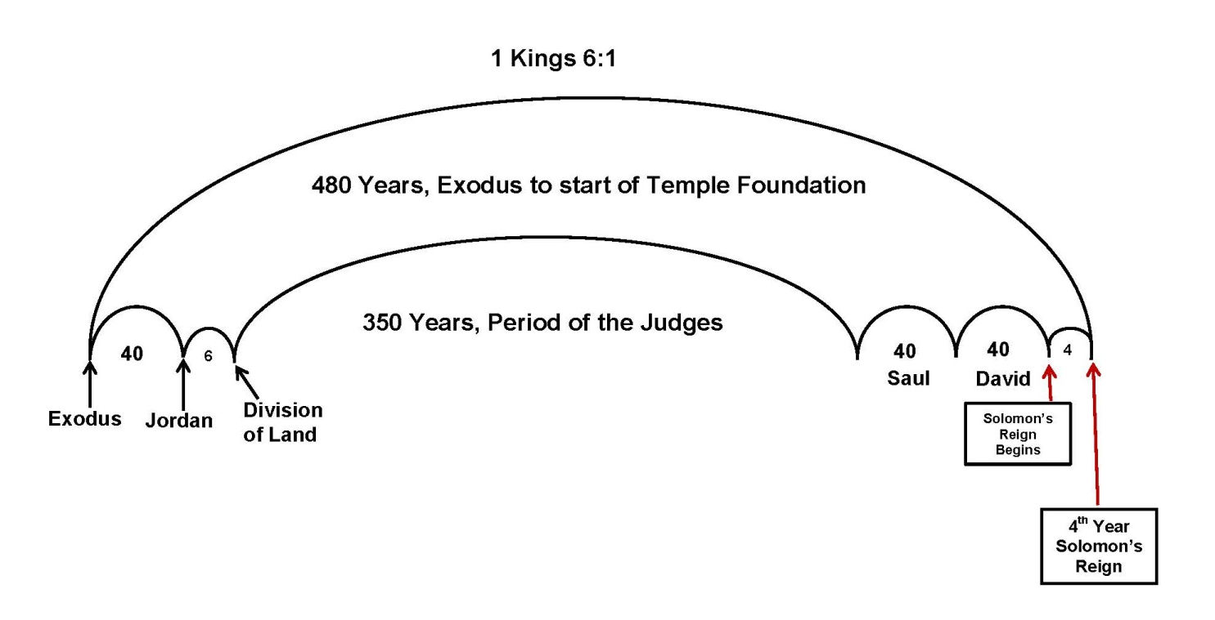

For without Acts 13:20, 1 Kings 6:1 is the only scripture we have that tells us definitively the length of the period of the judges, which is 350 years. Surely the Lord would want us to have an accurate scripture calculation of this important time period of the judges, for as Br. Russell mentioned, without Acts 13:20 it would be quite difficult to determine. For as he said, “The record of the judges given in the books of Judges and 1 Samuel, are disconnected, broken, lapped and tangled,” but we have Acts 13:20 that gives the time of the Judges.”

But now seeing Acts 13:20 doesn’t apply to the period of the Judges, we can see how 1 Kings 6:1 gives us the answer in one simple scripture. Now with this understanding it opens the way to easily calculate when 6000
years of mankind’s history of sin and death will be up.

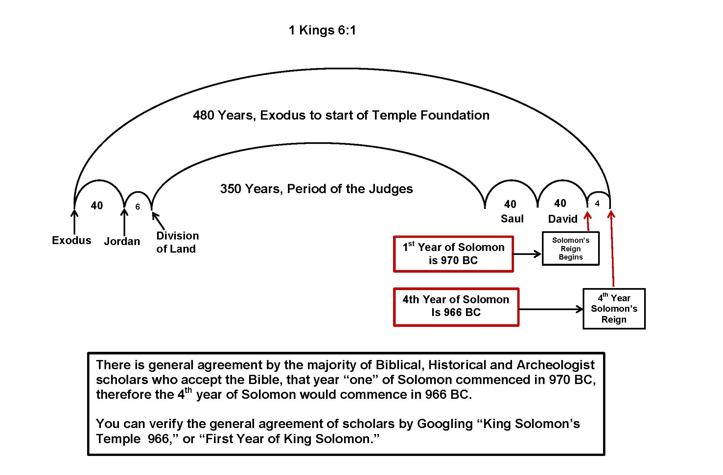
There is now general agreement by the majority of biblical, historical and archeologist scholars who accept the Bible, that year “one” of Solomon commenced in 970 BC, therefore the 4th year of Solomon would commence in 966 BC. A date that is also supported by the history of contemporary nations.

You can verify this general agreement of scholars by Googling “King Solomon’s Temple 966,” or “First Year of King Solomon.”

In our past chronology studies we often accepted the historical writings of one or two historian’s, to establish an important date in history for our chronology. On this Google site as well as others you’ll find not one or two historians, but page after page of many scholars who within a year or two concur that year one of Solomon’s reign was 970 BC and therefore 966 BC was the 4th year of Solomon’s reign.

Now if these many scholars are correct, and the date of 966 BC is accurate, (which we realize we won’t know positively until were beyond the vail,) we would have a simple uncomplicated scriptural verse by verse accounting to figure the number of years from Adam’s creation to when 6000 years of the reign of sin and death would be up.

Lets see how!

We recall our previous Vol. 2 chronology:
- 1656 years from Adam to the flood
- Then 427 years to the Abrahamic Covenant
- Then 430 years to the Exodus
- Now we add 480 years from 1 Kings 6:1 from the Exodus to the 4th year of King Solomon’s Reign.
- Which history tells us was 966 BC
- Thus we add 966 years to take us to the year AD 1

When we add these number of years together it totals 3959 years from Adams creation to AD 1, thus Adams creation would have been in 3959 BC.

To figure when 6000 years would be up, we merely need to subtract 3959 from 6000 = and we get 2041 AD. But to this number we have to add one year because there is no “zero” date between BC 1 and AD 1, which results in 2042 AD as the possible end of 6000 years from Adam’s creation.

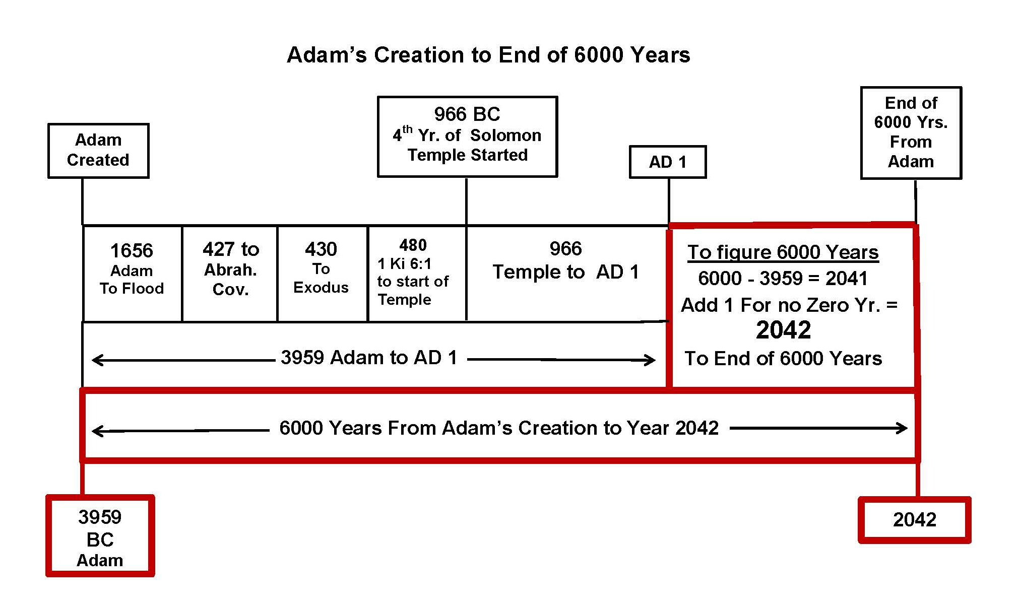

Thus we would have 6000 years from Adam’s Creation in 3959 BC to 2042 AD. Now let’s go back to our overall clarified chart

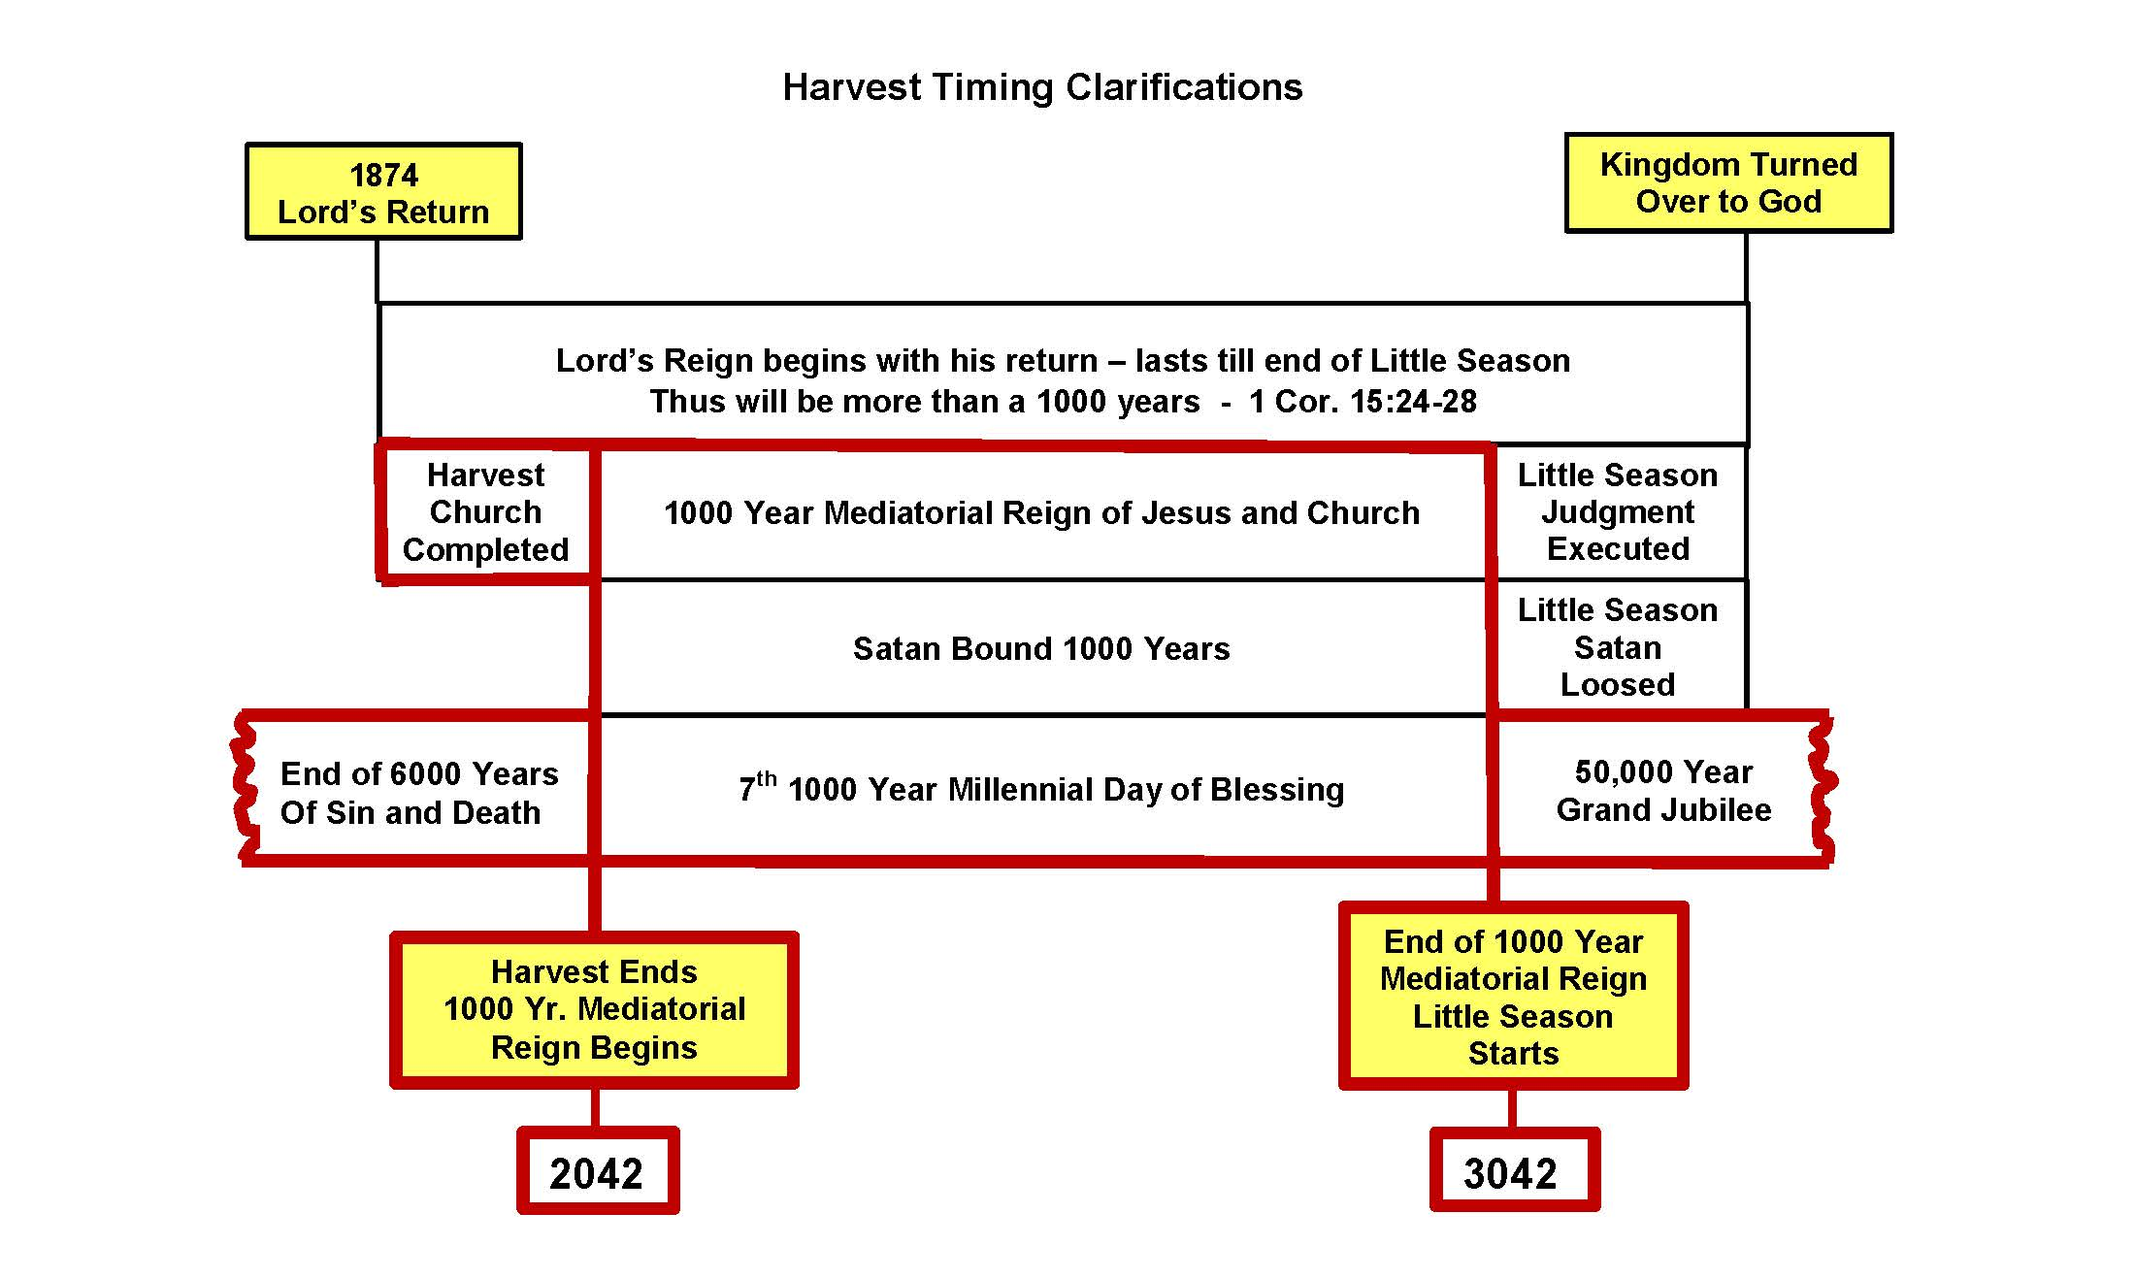

Could 2042 be a reasonable possible date for the end of 6000 years of sin and death, and in addition possibly indicating the end of the harvest?

We realize we won’t know positively until we’re beyond the vail.

But if it is, notice how beautifully it would complement and harmonize with the clarifications from Br. Russell’s writing we considered earlier.

- 6000 years of Sin and death would truly be at an end,
- For Satan would be bound,
- And It would immediately be followed the seventh 1000 year Millennial day of blessing
- Then followed by the 50th thousand year day
- and the Harvest being over it would also usher in the 1000 year Mediatorial reign of Jesus and the church
- And all who would pass their little season test will go on to live forever in perfect happiness.

****************************************
Thus the three 1000 year days would all be concurrent at the completion of the Harvest, and the end of 6000 years of sin and death.

Brethren I hope this don’t come across in any way as being dogmatic. I don’t know if it will prove to be true? The Lord laid it on my heart to share because it appears so simple, so harmonious with the clarifications Br. Russell made, and it seems to tie together many loose ends that perhaps crossed all our minds at one time or another.

But if it should be correct, think what it means. Our salvation is near at hand. Our longing for the blessings of the kingdom will soon be here. Pain and sorrow will soon flee away.

Brethren 2042 is only 27 years away. And we know the church will have to finish their course some time before all the end time prophecies take place.

Thus, perhaps allowing some 10 to 15 years for the church to be competed, leaving 12 years or so for all the end time prophecies to be fulfilled that will result in the complete removal of all the false systems of Babylon, and all the corrupt elements of Satan’s evil empire.

It can’t help but make each of us wonder how much time do I have left. Am I ready to be taken home soon?

My earnest prayer is that these clarifications might spurn us on to realize the Harvest message we all so love is still absolutely true, even though Br. Russell had to make a few clarifications. It will soon reach its glorious consummation! Soon our trials will be over. May we as a movement utilize whatever time we have left to strive with every fiber of our beings to make our calling and election sure, and work together to bring about the completion of the last members of the church.

Finally brethren, since this may be my last talk I want to express my love and appreciation to all of you in this wonderful ecclesia, for the privilege of serving as an elder for these past 51 years, and for all the countless blessings Florence and I have received from your nurturing and fellowship that we have enjoyed over these many years! We love you dearly!

George Tabac
900 Brentwood Dr.
Bensenville, Illinois 60106
USA

e-mail: gtabac@comcast.net

Phone: 630-595-0984

MEDIATORIAL REIGN ARTICLES
100% Consistent in stating
1. The Mediatorial reign cannot begin until the Church is complete, and blood is applied to Justice.
2. The reign will last for 1000 years,
3. Satan will be bound during the 1000 year Mediatorial reign.

CONVENTION REPORT SERMONS of Br. Russell

Convention Reports -46
When the Church has finished her course here, then the blessings will go to all the world at the hands of the Great Mediator, and at the end of the Millennial age, the mediatorial work will be finished, and the kingdom will be turned over to the Father and the world will be tested just as Adam was.

CR – 96
As soon as this work shall have been accomplished, the great Mediator, the antitype of Moses (Acts 3:22,23), raised up from amongst his brethren, will be completed. Then the Mediatorial Kingdom will begin the blessing, uplifting and reconciling of the world.

CR – 113
Messiah's empire will be a mediatorial one and, according to the Scriptures, will continue only one thousand years

CR – 150
There will be by and by a way in which the whole world will come to God through the great Mediator, through the mediatorial kingdom, through the great work which Christ as Mediator will accomplish for a thousand years, of instructing, and chastening, and helping mankind-- all the world will have a chance in that.

CR 485
When Moses was preparing to mediate the Law Covenant, he took the blood of bulls and of goats, and sprinkled first the
tables of the Law and afterward all the people of Israel. (Exodus 24:3-8.) Thus the Law Covenant was established, bringing the people into covenant by the great antitypical Moses, Christ, who first satisfies God's Justice, represented in the books of the Law, and then, during the thousand years of His Mediatorial Reign, will sprinkle "all the people," the world, with the blood of the "better sacrifices"-- those of The Christ, Head and Body—thus bringing the world into covenant relationship with God.-- Hebrews 9:15-23.

QUESTION BOOK

QB 168 That procedure at the end of the Gospel Age is represented by the Lord in the Tabernacle Shadows as the sprinkling of the blood of the goat, which is "for the sins of the people," and then the conditions of the New Covenant will be made applicable for all the world through Israel. He will deliver over to the Father all things, that He may be "all in all," and that all may be directly subject to Him. During the thousand years, however, under Christ's Mediatorial arrangements, The New Covenant will begin its work at the beginning of the Millennial Age, and continue its work of reconciling the world and destroying in death those who will not come into harmony with its arrangements, so that at the end of the Millennium, the whole world can be presented blameless before the Father.

QB 168
God will then be satisfied as respects the sins of the whole world, and the whole world will
consequently he turned over to Jesus as the Mediator, and His kingdom will be the only rule throughout he thousand years of the mediatorial reign.

QB – 406
He will deliver over to the Father all things, that He may be "all in all," and that all may be directly subject to Him. During the thousand years, however, under Christ's Mediatorial arrangements,

QB – 467
There can be no mediatorial work between God and men until the Body of the Christ is complete and the mediatorial kingdom begins, and it will last through all of the thousand years, then the mediatorial kingdom will be at an end,

QB 560
The next step in its application will be, not the imputation, but the actual giving of this to the world, bringing them up out of their imperfection, during the thousand years of the Mediatorial reign; bringing them back into that condition in which they shall be in harmony with God, even as Adam was in harmony with him before the fall.

QB 571
QUESTION (1916)--2--Will the merit of
Christ in any sense of the term be imputed to the world of mankind during the mediatorial reign?

ANSWER--There will be no imputation of Christ's merit during the Millennial reign. Not a bit. Because there will not be anything to impute. Why not? Because it will all have been given at the beginning. When a thing is given up you can't do any more with it. Suppose you had a million dollars with which you intended to found or operate a great work and you made ready everything in time, and that million dollars was in the bank and all ready to apply for that purpose. And suppose then you delivered it over to the committee that had to do with this great enterprise. Now the moment you turned it over to the committee you have nothing more to do with it, have you? And so Jesus with the inauguration of the Millennium will turn over the full merit of His sacrifice. It
will all be given over to Justice. Justice will have turned over mankind to Jesus. Jesus will have no more merit in the hands of Justice after that to apply to anybody, impute or give to anybody. It will all be given. It must be given at the very beginning of the Millennial Age.

QB 575
The imperfect, fallen men, fallen through weaknesses of Father Adam, will all under the mediatorial reign of Christ have been brought up to perfection. Then they ought to be able with all the experience behind them, they ought to be able to maintain it. Because God would not ask any unreasonable or unjust requirement of any creature. And so at the end of the thousand years they will be tested .

QB 406
During the thousand years, however, under Christ's Mediatorial arrangements…

QB – 467
There can be no mediatorial work between God and men until
the Body of the Christ is complete and the mediatorial
kingdom begins, and it will last through all of the thousand
years, then the mediatorial kingdom will be at an end,

QB 467
So, the Lord Jesus is the Head and He will have a body, which He is now preparing during this gospel age, and
that whole body will be with Him as Mediator during the Millennial Age, and then will be the mediatorial kingdom.

OVERLAND MONTHLY BOOK
OM 189
The unwilling and disobedient will be destroyed in the Second Death. At the close of the thousand years, Christ's Mediatorial Kingdom will terminate.

OM 254
The Church is called out of the world under a Divine invitation to suffer with Christ in the present life and during this Gospel Age and then to reign with Christ during the Millennial Age, participating in His Mediatorial Kingdom for the blessing, uplifting, salvation of the world.

1909 Bible Student Convention Report Question 144 Br. Russell
So, the Lord Jesus is the Head and He will have a body, which He is now preparing during this gospel age, and that whole body will be with Him as Mediator during the Millennial Age, and then will be the mediatorial kingdom. There can be no mediatorial work between God and men until the Body of the Christ is complete and the mediatorial kingdom be-gins, and it will last through all of the thousand years, then the mediatorial kingdom will be at an end,

1909 Bible Student Convention Report Question 154 Br. Russell’s answer
God will then be satisfied as respects the sins of the whole world, and the whole world will consequently be turned over to Jesus as the Mediator, and His kingdom will be the only rule throughout the thousand years of the mediatorial reign. The New Covenant will begin its work at the beginning of the Millennial Age, and continue its work of reconciling the world and destroying in death those who will not come into harmony with its arrangements, so that at the end of the Millennium, the whole world can be presented blameless before the Father.

The Great Mediator between God and man - The Christ of glory - will fill his mediatorial office for a thousand years and complete it only by the end of that time, when he will deliver over to the Father, fully reconciled, all who can be brought into harmony with the divine arrangement.

1910 Convention Report – Br. Russell’s discourse 1000 Year Med. Reign
Then for a thousand years Christ's Mediatorial Kingdom will put down all insubordination and destroy every foe of righteousness and truth that will not submit; the last enemy that will be destroyed is death.

Convention Report Sermons P-113 Discourse of Br. Russell – The Desire of All Nations"
According to the Bible the reign of the promised Great King shall not be an eternal reign. Eventually the dominion of earth originally given to Adam and lost by disobedience and consequent incapacity, is to be restored to such of Adam's race as shall attain earthly perfection and Jehovah's approval. Messiah's empire will be a mediatorial one and, according to the Scriptures, will continue only one thousand years.

HARVEST GLEANINGS BOOK
HG 1 Page 458 Br. Russell Discourse “God’s message of Comfort to the Jews”
In other words, although Messiah's Kingdom will be a mediatorial one, separate from that of Jehovah, for the purpose of putting down sin and of uplifting the sinner, nevertheless throughout the thousand years of his glorious reign he will represent Jehovah in that his entire work will have the full approval of Jehovah and be conducted along the lines of the Divine Law.

HG 1 Page 460 Br. Russell’s discourse 1000 Year Mediatorial Kingdom
The Hebrew prophets had foretold this greatness of the Messiah, who at the Divinely-appointed hour will assume the dominion of earth, setting up by Divine authority his Mediatorial Kingdom, which, for a thousand years, will reign triumphantly, binding Satan and sin in its every form and setting at liberty every good principle of righteousness for the blessing of Israel under the New Covenant.

HG 1 Page 497
In the symbolic language of Revelation, Messiah's reign is described as a glorious opportunity for all mankind to come back into harmony with the Almighty and to attain everlasting life through the great Mediatorial Kingdom. The symbolic picture of which this text is a part, describes the establishment of Messiah's Kingdom, the saints of this Gospel Age being with Him in His throne, in His Kingdom, reigning with Him-a Royal priesthood. Rev. 20:1-6 The context further describes that period, in which all mankind shall be brought to a knowledge of the Truth, when all shall "stand before the great White Throne," Messiah's Judgment Throne, to be tried, to be tested, to be proven whether they will accept or refuse the perfection and eternal life which Divine mercy will then make possible for them. During that thousand years of Messiah's reign, as we have seen, death will be gradually swallowed up in victory.

Harvest Gleanings -2
According to the Scriptures, they will be succeeded by the Kingdom of God’s dear Son — the Millennial Kingdom — the Mediatorial Kingdom—for which we pray, “Thy Kingdom come; thy will be done on earth, as it is in heaven.” Matt. 6:10 And when Christ’s mediatorial Kingdom shall be at the end of the Millennium, delivered back to God, even the Father, God’s Kingdom will have fully come in the earth.

Harvest Gleanings 2
The Throne is Messiah’s. It represents His Mediatorial Dominion of earth for a thousand years.

Harvest Gleanings 2 Sub-heading “God had appointed a Day.”
It is the thousand-year day of Christ, the period of His mediatorial reign, in which Satan will be bound, all evil influences be removed and the light of the knowledge of the glory of God be made to fill the whole earth.

Harvest Gleanings 2
It is needless to say that our text is one of the symbolisms of a Book filled with symbols. God’s people, guided by His holy Spirit, in due time will appreciate these symbols. For many of them the due time is already here. The Throne is Messiah’s. It represents His Mediatorial Dominion of earth for a thousand years.

HG3 481
Now we are seeing that the salvation that God has promised will be brought to us at the second coming of Jesus and the establishment of His Mediatorial Kingdom for the blessing of all the families of the earth! Now we are seeing that the salvation provided is a resurrection of the dead not merely an awakening from the tomb, but a complete uplift out of sin and degradation to the full perfection of human nature in the earthly likeness of the Creator. Now we are seeing that this great blessing has been set apart by the Almighty as the work of the great Sabbath Day of a thousand years, in which “the last enemy to be destroyed is death.”

HG3 689
He (Satan) is now the prince or ruler of this world, proven worthy of eternal destruction (John 12:31; Heb. 2:14) which will overtake him at the close of Christ’s mediatorial reign (Rev. 20:9, 10). During that thousand years Satan is to be bound, and will be loosed at the end of it,

HG3 722
By nature we are all children of wrath, sinners under sentence of death. God indeed tells us that He purposes to bless the world by and by, through the great Mediatorial Kingdom that will rule the world for a thousand years to help mankind up out of degradation, sin and death to full perfection of human nature; and that He has appointed Jesus Christ to be the Mediator between Himself and the world during those thousand years.

PASTOR RUSSELL SERMON BOOK
Pastor Russell Sermon Book page 503
Messiah's Empire will be a Mediatorial one and, according to the Scriptures, will continue only one thousand years. But we are assured that the period will be quite sufficient for the great work to be accomplished.

Sermon Book Page 692
God's people, guided by His Holy Spirit, in due time will appreciate these symbols. For many of them, that due time is already here. The Throne is Messiah's; it represents His Mediatorial Dominion of earth for a thousand years. Its whiteness symbolizes the purity, the justice, of His Kingdom of Righteousness under the whole heavens.

REPRINTS

R2304 : page 143
The mediatorial Millennial Kingdom of Christ and the Church, having accomplished its purpose, and being withdrawn, the dominion of the renewed earth will be handed over to the rule of its redeemed and restored rulers--humanity.

R 4578 Page 92
The merit of the Ransom will be applied for the world indirectly in the sealing of the New Covenant with Israel, so that all the world under that Covenant provision and under the great Mediatorial Kingdom of Righteousness, for a thousand years may have fullest opportunity for the opening of the eyes of their understanding.

R4586
"Soon the antitypical Atonement Day will end and satisfaction for the sins of the world will be made. Forthwith the world will be turned over to him, and his Mediatorial reign will begin…He will reign or mediate for a thousand years."

R 4631 Page 197
He will then satisfy Divine Justice by making application of his merit for the sins of all the people. In consequence of that satisfaction, they will all be turned over to him, and his Millennial Kingdom will begin. During that thousand years the Mediator, Christ the Head and the Church his Body, Christ the Bridegroom and the Church the Bride, his joint-heir, will reign for the uplifting of mankind out of sin, degradation, death--up to perfection of mind, body and morals.

R4729
On the contrary, the great Mediator will, during the thousand years of the Mediatorial Kingdom, instruct and reward and bless and uplift all the willing and obedient,

R-4586 C2-P4,5:
"Soon the antitypical Atonement Day will end and satisfaction for the sins of the world will be made. Forthwith the world will be turned over to him, and his Mediatorial reign will begin…He will reign or mediate for a thousand years."

R-4612
Instead of Israel's being justified instantly to fellowship with God, they will be under the care and control of the great Mediator between God and men. And this great Mediator, Prophet, Priest and King will for one thousand years be engaged in the work of taking away their sins, according to this Covenant which God specified through the Prophet Jeremiah. And at the conclusion of the one thousand years he will present them perfect, blameless, irreprovable to the Father.

R-4640
Then for a thousand years Christ's Mediatorial Kingdom will put down all insubordination and destroy every foe of righteousness and truth that will not submit; the last enemy that will be destroyed is death.

R 4646
Then for a thousand years Christ's Mediatorial Kingdom will put down all insubordination and destroy every foe of righteousness and truth that will not submit; the last enemy that will be destroyed is death.

R 4648
God's dealings with the Church during this age, introduced into covenant relationship to the Father by the great Advocate, and his dealings with Israel and the world during the thousand years of the great Mediatorial Kingdom…

R-4729
On the contrary, the great Mediator will, during the thousand years of the Mediatorial Kingdom, instruct and reward and bless and uplift all the willing and obedient,

R-4780
The next step in its application will be, not the imputation, but the actual giving of this to the world, bringing them up out of their imperfection, during the thousand years of the Mediatorial reign.

R-4903
At the close of the Mediatorial reign all mankind will be ready to profit by the experiences of the Millennium and will be turned over to God, to Divine Justice.

R 4999
God's people, guided by His Holy Spirit, in due time will appreciate these symbols. For many of them, that due time is already here. The Throne is Messiah's; it represents His Mediatorial Dominion of earth for a thousand years. Its whiteness symbolizes the purity, the justice, of His Kingdom of Righteousness under the whole heavens.

R 4999
The fact that this testing of mankind will be after the end of the thousand years of the Mediator's reign, when He shall have delivered up the Kingdom to the Father, does not prove that the glorified Jesus will have nothing to do with the destruction that will come upon Satan and those obedient to Him. Quite to the contrary. As Jesus was the Divine Agent, Instrument, Word, Mouthpiece, Logos, in all the work of creation, and prior to undertaking the Mediatorial work, so, highly exalted now in honor, next to the Father, and at His right Hand of Power, He will undoubtedly be the Father's Representative in that judgment upon the wilful sinners, who with Satan will be consigned to the Second Death.

R 5000
During the entire thousand years of the reign of Christ upon His Mediatorial Throne the work of sprinkling the people--the work of justifying them, making them acceptable, cleansing them from sin, and bringing them into relationship with the Covenant and its demands of perfect obedience--will be in process.

R 5000
All who will accept Him and the gracious arrangements of His Mediatorial Kingdom will attain the highest blessings promised to their nation, and become associated in the Kingdom, which for a thousand years will bless all people with the gracious opportunity for returning to Divine favor on the same terms—obedience to the extent of ability and faith in the Redeemer.

R_ 5074
But since human perfection--to the world of mankind—will come only under the Mediatorial reign of Christ, the Ancient Worthies cannot be introduced to the Father until the close of the Millennial Age. Hence they will not have life in its fullest sense until the time when at the close of the Millennial Age the Kingdom shall have been delivered over to the Father. What they will have in the meantime--during the thousand-year period--will be perfection of human nature and all the blessings that God provides for mankind through the great Mediator.

R-5074
God has included the whole world in the Mediatorial work of Messiah, as He has included all the Church in the preparatory work of the Royal Priesthood, through the great Advocate, the Redeemer; and the Mediator's work will continue for a thousand years

R-5317
During the thousand years, however, under Christ's Mediatorial arrangements, the Ancient Worthies, perfected, and all others, in proportion to their attainment of perfection, will enjoy privileges and blessings, because they will no longer be under a reign of sin and death and of Satan, the "Prince of this World," but under the Prince of Life and His reign of Righteousness, unto Life.

R-5928
The Great Mediator between God and man--The Christ of glory--will fill His mediatorial office for a thousand years and complete it only by the end of that time, when He will deliver over to the Father, fully reconciled, all who can be brought into harmony with the Divine arrangement.

R-5973 C2-P6
Mediatorial Restitution Blessings However Must Await Completion Of Church
Question.--"Would it be proper for us to suppose that the world might begin to receive its share of restitution blessings while some of the members of the church are still in the flesh?

Answer.--No! This would be an impossible thought. The whole merit of Christ is mortgaged by the imputation which Jesus has made of his merit to the company consecrating during this age. This mortgage must be released fully, completely, before the New Covenant can be sealed and put into operation for giving restitution blessings to Adam and his race."

In other words the Restitution BLESSING PHASE, cannot begin till the Church is complete. Only the preparatory phase is in operation now.

Additional Reprint Quotes Stating 1000 Year Reign Yet Future 11-23-2015

R-86 – April 1880
The bruising of satan (“under your feet”), Rom. 16:20, and the destroying of death, have both been deferred until the body of Christ (the church) is complete. With the first resurrection, that company, “the Royal Priesthood,” is complete, and their work is before them. That work includes the binding of Satan, the destruction of death; i.e., the “swallowing up of death in victory,” and the restoration of mankind to harmony with God, and to that condition of life enjoyed before sin entered—a condition of at one-ment.
This work of restoration apparently occupied all of the thousand years (Rev. 20:4), since it is called “the times (years) of restitution.”

R-1351 January 1892
But in due time these prospective heirs of the kingdom who now faithfully endure hardness as good soldiers, will be counted worthy to be exalted and to reign with Christ when his kingdom shall be established in power and great glory. (Matt. 24:30.) Hear the promise of our glorified Lord: “To him that overcometh, will I grant to sit with me in my throne.” (Rev. 3:21.) And again, “They shall be priests of God and of Christ and shall reign with him a thousand years”—“on the earth.”—Rev. 20:6; 5:10.

R-1718 – October 1894
…that the Kingdom cannot come until the Church has been completed,—and that not until then can “all the families of the earth be blest” with the promised Millennial blessings and opportunities.—Luke 12:32; Rev. 20:4; Gen. 28:14.

R-1766 – February 1895
But those who already feel some of the boycott, and those who soon will feel still more of it, may take comfort in the Lord’s appreciation of their fidelity as expressed in the promise of Rev. 20:4,—that of such are the heirs of God and joint-heirs with Christ in the Kingdom soon to be established for the blessing of mankind, the restitution of all things.

R- 1908 - December 1895
“The sure word of prophecy” indicates that in 1878 it began to be established and that the process of establishment will be from that date to 1915, when the Kingdom in its glory of power and righteousness will have come. The true Church, whose names are “written in heaven,” and which have not been blotted out because of unfaithfulness (Luke 10:20; Rev. 3:5) will then be exalted to reign with Christ. They shall be like him, and see him as he is, they shall reign with him a thousand years, and they shall judge the world in righteousness and bless all the families of the earth.—1 John 3:2; Rev. 20:6; Isa. 32:1; Gen. 28:14; Gal. 3:16,29.

R-2247 – January 1898
That the present Gospel age is intended merely for the selection of a “little flock”along a “narrow way”which “few”find and still fewer care to walk in; (3) That another age of a thousand years is to follow this and be the Kingdom age, in which Christ and the “little flock,”developed in the Gospel age, will be the world’s instructors and judges—“kings and priests unto God”(Rev. 1:6; 5:10; 20:6)

R-2428 – January 1899
We hold that the masses in down town New York, not possessing this knowledge, but being blinded in their minds by the “god of this world” (2 Cor. 4:4), are not on trial now, as are we who have this knowledge, but will have their trial by and by, during the Millennial age, at the same time with the “heathen” millions of Asia and Africa;—after Satan has been “bound” and deceives the peoples no more (Rev. 20:1-4), after the Lord and his elect Church have begun the reign of righteousness.
R-2739 – December 1900
QUESTION:"I understand from Rev.20:4-6, that Christ will reign 1000 years, and from verses 2-7 that Satan will be bound during that period. If Christ began to reign in 1878, and Satan will not be bound until 1915, the two periods do not seem to synchronize; and furthermore, both extend beyond the 7th 1000 year period which according to our Bible chronology, began in the Autumn of 1872. How is this? Can you assist me?

ANSWER: Apparently this matter of when the 1000 year period should be reckoned as fully beginning and fully ending will be an open question until the close of the Millennial age.
The scripture declaration respecting the saints, the overcomers is, 'They lived and reigned a 1000 years.' The reign of the saints cannot be properly be said to begin before all the 'jewels' have been gathered, nor before 'the times of the Gentiles' end in 1914. Nor is it said that their reign will be no longer than a 1000 years. After the 1000 years Satan shall be loosed and the above trial shall ensue; but the reign of Christ and the church will evidently continue long enough after the 1000 years to destroy all found unworthy in that final test, and to thus complete the work for which this reign is instituted.

R-3073 – September 1902
In order that eventually all may see to what lengths Selfishness would lead—ultimately wrecking the present order—social, political, financial and religious—and thus preparing for the establishment of Christ’s Millennial Kingdom of love and righteousness upon the ruins of Satan’s dominion and the binding of Satan that he may “deceive the nations no more until the thousand years are ended.”—Rev. 20:1-4.

R-4635 – June 1910
The “harvest” time will be the end of this age, just before the inauguration of the new age of Christ’s Millennial Kingdom. The wheat class will be those counted fit to be associated with Christ in the glory of his Millennial Kingdom, and the gathering into the “barn” or garner represents the resurrection change which this wheat will experience.

R-5023 – May 1912
Question: "Is it scriptural to say that the glorified members of the church have reigned at any time up to the present?
Answer: No! They have not reigned at any time….The reign of Christ did not in any sense begin in the past…When the reign of Christ begins, you will find it such a thorough reign that all the members of his body will have some part in it.

R-5115 C2-P1
"When will the promised time come in which 'Thy will shall be done on earth as in heaven?' The Scriptures reply that the glorious time for the blessing of the world will not come until the church shall have passed into glory; that Messiah will then reign for a thousand years."

R-5179 – February 1913
The First Resurrection began with our Lord Jesus and is not yet completed, because all of the faithful Elect Bride class are called to share in His sacrificial death, and to share also in His glorious Resurrection to the Divine nature. All sharing in that First Resurrection, the Bible declares, will reign with Christ a thousand years, and as the Seed of Abraham, fully empowered, will bless all those redeemed by the precious blood of Calvary.—Rev. 20:4.

R-5190 – February 1913
I am the more encouraged because I realize that the great Day of Blessing, the great Thousand-Year Day of Messiah’s Kingdom, is near at hand—is dawning now. Soon Satan, the “Prince of Darkness,” will be bound for a thousand years, to deceive the nations no more. (Revelation 20:2,3,6.)
R-5263 – June 1913
The loyal band following in His footsteps in the Narrow Way, seeking, according to the Divine promise, glory, honor, immortality and joint-heirship in Messiah’s Kingdom, are also men of destiny. But their destiny has not yet been attained. It is for them to wait until the full number of the elect Church shall have been called, chosen and proved faithful. Then their destiny will be reached by the glorious change of the First Resurrection; for “flesh and blood cannot inherit the Kingdom of God.” By their change they will be perfected in the Divine nature like their Master. (2 Peter 1:4.) O glorious destiny! United, or married, to their Lord on the Heavenly plane, they will be His joint-heirs, a Royal Priesthood, to reign with Him a thousand years for the very purpose of blessing the world of mankind, for whose recovery Christ died.—Revelation 20:6.

R-5314 - September 1918
In a word, God’s proposal is that Messiah’s Kingdom, the members of which are now being selected from the world—the Church, the Bride—will for a thousand years, with the Redeemer, bless and uplift and restore all the nations of earth—from sin, degradation, death, the tomb

R-5604 – January 1915
WE HAVE heretofore pointed out that the great Battle of Armageddon—the anti-typical one—is near—that it will quickly follow the present world-war. Today’s Study relates to the first of the great battles in the Valley of Megiddo, noted for its many slaughters, and therefore made the basis of the Divine prediction respecting the “Time of Trouble such as was not since there was a nation,” which will precede and prepare the way for Messiah’s glorious Rule of a thousand years.—1 Cor. 15:24-26; Rev. 20:6.

R-5692 - May 1915
Their reigning, their power and their control in the world’s affairs will not come until they shall have experienced the resurrection change, and Messiah’s Kingdom shall be fully inaugurated. Then these shall live and reign with Christ a thousand years.—Revelation 20:4.

R-5919
"The kingdom cannot come until the royal family is ready to take the throne. Jesus, indeed, had long been ready; but in harmony with the Father's plan he has waited and has been doing a work in the preparation of the church, his brethren, who are to be his joint-heirs in the kingdom -- otherwise styled "the bride, the Lamb's wife." (Romans 8:17; Rev. 21:9,10) Then for a thousand years the restitution privileges will be open to the whole world of mankind."

